**Operating Systems** (Programming Project)



Instructor: Dr. Hanh Pham

Write a program in JAVA (in Mallocator.java file) to implement three Memory Allocation Methods: FF,BF,WF. This program should read input data about available memory blocks of RAM in “Minput.data” text file and about processes which need to be loaded to RAM in “Pinput.data” text file (see the format below) and produce the memory allocations for new processes in using these methods in three output files: “FFoutput.data”, “BFoutput.data”, and “WFoutput.data” files (see the format below). Attention: whatever inside () is only for explanation and should not be present/printed in the data files.

Format for “Minput.data”:

3 (#of free memory slots)

100 400 (addresses of start and end of a free memory slot => size 300)

600 800 (addresses of start and end of a free memory slot => size 200)

1500 1900 (addresses of start and end of a free memory slot => size 400)

Format for “Pinput.data”:

3(# of processes)

1 (ID of process) 190 (size of process)

2 (ID of process) 210 (size of process)

3 (ID of process) 205 (size of process)

Format for “FFoutput.data”, “BFoutput.data” , and “WFoutput.data” 100(addresses of start) 310(addresses of end) 2(process ID)

600(addresses of start) 790(addresses of end) 1(process ID)

1500(addresses of start) 1705(addresses of end) 3(process ID)

-0 (means all are allocated, or -1,3 if processes 1 and 3 can't be allocated)

Format of the report of the project:

+Title page: student name, memory allocation methods

+Table of contents

1. Description of algorithms (also give an example)
2. Description of implementation (your program)
3. Experiments: run your program with 2 different input data sets, provide 3 results (one for each of the FF, BF, WF methods) for each data set, and draw charts (one for each of the FF, BF, WF methods) based on those, for each set.
4. Conclusions
5. References

**WHAT TO SUBMIT:**

1. Report file in word format (named as “LastName-FirstInitial.doc”) separately from
2. ZIP/RAR file (named as “LastName-FirstInitial.zip/rar”) which contains a folder with at least the following files:
   * Minput.data, Pinput.data
   * FFoutput.data, BFoutput.data, and WFoutput.data
   * Mallocator.class (executable code)
   * Mallocator.java (source code)

**WHERE TO SUBMIT:** Blackboard **DEADLINE:** 11:55pm of the day of the last lab for this PROJECT

**NOTE:** For each lab based on this project, at the end of each lab: submit a zipped file of your working folder which includes everything including the report file, to show your progress. For the project itself final version of report, software and data must be submitted (11:55pm of the day of the last lab based on this project).

Page **1** of **3**

**EXAMPLE: < In the REPORT : >**

|  |  |  |  |
| --- | --- | --- | --- |
| **3. EXPERIMENTS:** | |  |  |
| Experiment #1: | |  |  |
|  |  |  |  |
| **a) INPUT Data:** | | "Minput.data" |  |
|  |  |  |
|  |  | 3 |  |
|  |  | 100 400 |  |
|  |  | 600 800 |  |
|  |  | 1500 1900 |  |
| **b) Charts** : | |  |  |

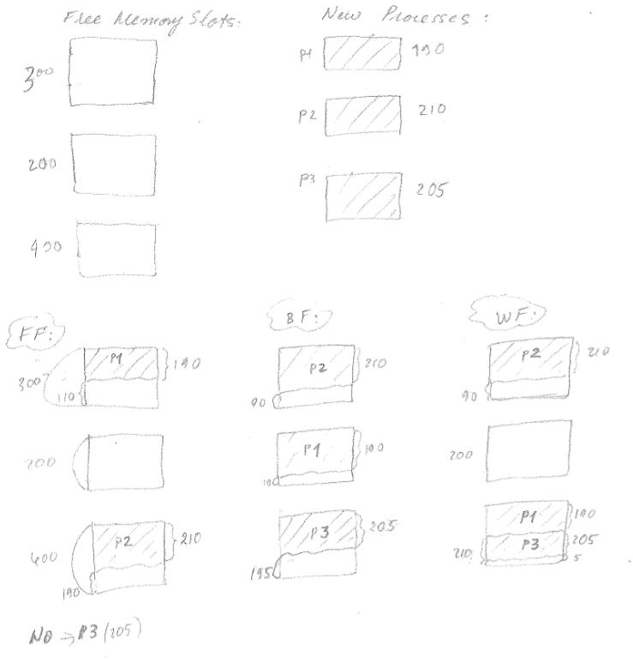

"Pinput.data"



3

1. 190
2. 210
3. 205

Page **2** of **3**

**c) SHOULD-BE Output:**

“FFoutput.data“

100 290 1

1500 1710 2

-3

“BFoutput.data“

100 310 2

600 790 1

1500 1705 3

-0

“WFoutput.data“

100 310 2

1500 1690 1

1690 1895 3

-0

**d) MY Output (produced by my program):**

“FFoutput.data“

100 290 1

1500 1710 2

-3

“BFoutput.data“

100 310 2

600 790 1

1500 1705 3

-0

“WFoutput.data“

100 310 2

1500 1690 1

1690 1895 3

-0

Page **3** of **3**